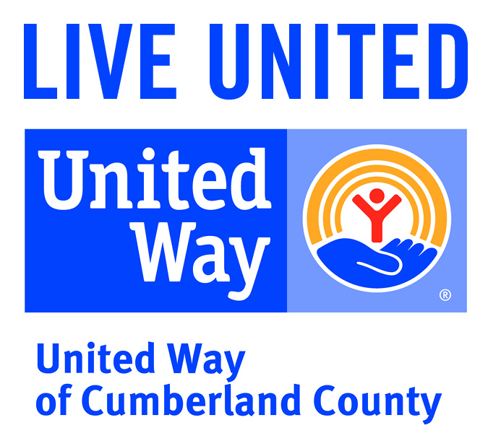
222 Maiden Lane
Fayetteville, NC 28301
Tel 910.483.1179
www.unitedway-cc.org

Cumberland County Awarded Federal Funds
Under Phase 38 of the
Emergency Food and Shelter Program

Cumberland County has been awarded $1127,619 under Phase 38 of the Emergency Food and Shelter Program (EFSP) to help supplement and expand local emergency food and shelter programs. Local Recipient Organizations use EFSP funds for mass shelter, mass feeding, food distribution through food pantries, food banks and food vouchers, pass due utility payments to prevent service disconnections, past due rent/mortgage assistance to prevent evictions and to assist people that are leaving shelters with establishing stable living conditions. Residents in need of assistance must contact the agency directly to check for availability of funds.

Cumberland County Local Recipient Organizations under Phase 38 are the following:

Action Pathways Second Harvest Food Bank (Weekend Back Pack Feeding Program) $18,000
Catholic Charities of the Raleigh Diocese (Emergency Food Assistance Program) $20,000
Cumberland Disaster Recovery Coalition (Utility Assistance Program) $ 9,000
D’Vine Concepts A-Z, Inc. (Emergency Food Assistance Program) $ 2,500
Operation Blessings of Fayetteville $20,167
(Rental/Mortgage Assistance Program - $12,000)
(Utility Assistance Program - $9,000)
St. Ann Catholic Church (Alter Rosery Homeless Feeding Program) $ 5,400
The Salvation Army (Emergency Shelter Program) $50,000
United Way of Cumberland County (Administration of EFSP Program) $ 2,552

Total $127,619

About Emergency Food & Shelter Program:
The Emergency Food & Shelter Program is a Federal program administered by the U.S Department of Homeland Security’s Federal Emergency Management Agency (DHS/FEMA). It has been entrusted through the McKinney-Ventro Homeless Assistance Act (PL 100-77) “to supplement and expand ongoing efforts to provide shelter, food and supportive services” by local social service organizations for people across our Nation who are hungry, homeless, and in economic crisis. The EFSP National Board designated United Way of Cumberland County to serve as the administrator to the Local EFSP Board. Representatives from the following organizations are mandated to comprise the Local EFSP Board: American Red Cross; Catholic Charities USA; The Jewish Federations of North America; National Council of Churches of Christ in the USA; The Salvation Army; United Way of Cumberland County; Homeless Agency Representative; Native American Agency Representative; Government Agency Representative; and Aging Council Agency Representative.

About United Way of Cumberland County:
United Way of Cumberland County’s mission is to improve the quality of lives in Cumberland County by addressing critical human needs.

United Way of Cumberland County strives to advance the common good by focusing on the building blocks for a good life: education, financial stability, health and support of critical basic needs. At United Way, we recognize that lasting changes are achieved by addressing the underlying causes of problems. United Way partners with other nonprofit agencies to improve lives right here in Cumberland County.

Give. Advocate. Volunteer. LIVE UNITED.
###

