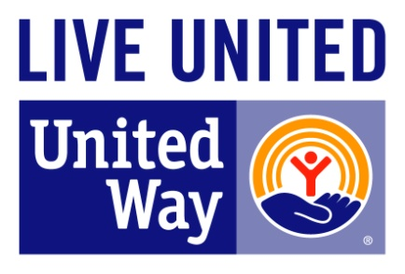
United Way of

Cumberland County

559 Executive Place, Suite 101
Fayetteville, NC 28305
Tel 910.483.1179
www.unitedway-cc.org

FOR IMMEDIATE RELEASE CONTACT: Crystal Moore-McNair, Community Impact Director
July 15, 2024 910.483.1179 ext. 229
crystalmmcnair@unitedway-cc.org

Community Leaders Graduate from United Way of Cumberland County’s
Leadership Development Program

FAYETTEVILLE, NC: Thirty community volunteer leaders received certificates of completion from United Way of Cumberland County’s 2024 Leadership Development Program. To date, the Program has graduated over 486 volunteer leaders, of which, more than 300 are currently serving on local civic and nonprofit boards, committees, and commissions throughout Cumberland County.

The Leadership Development Program was initiated to identify, enhance leadership skills, and place diverse volunteer leaders in leadership and policy decision-making roles within nonprofit and civic organizations throughout Cumberland County. The program is designed around ten, two-hour information-sharing sessions held weekly and facilitated by experienced professional community leaders. The weekly information-sharing sessions cover a range of topics including: leadership & team building; board member legal & financial responsibilities; nonprofit marketing & communications; program evaluation; community building & strategic planning; board member responsibilities & Robert’s rules of order; responsibilities of volunteerism; board diversity, equity & inclusion; grant development & research; and fundraising/grant writing for nonprofits.

For more information about our graduates and the Leadership Development Program please contact the United Way of Cumberland County at 910-483-1179 or visit our website: www.unitedway-cc.org. Follow this link. _____________ to view photos from the 2024 graduation ceremony.

2024 United Way of Cumberland County Leadership Development Program Graduates

