**Ways to Give this GivingTuesday**

**1. Credit Card**

* **Online Donation:** Give **$25 or more** through our online catalog. Click on the **Donate Now** button available from **November 25th at 9 AM to December 4th at 5 PM**.

**2. Check**

* **Mail Your Check Today:**Write your check payable to **Cumberland Community Foundation** with "GivingTuesday - United Way" in the memo line. Please mail your checks to ensure they arrive before the matching deadline:  
  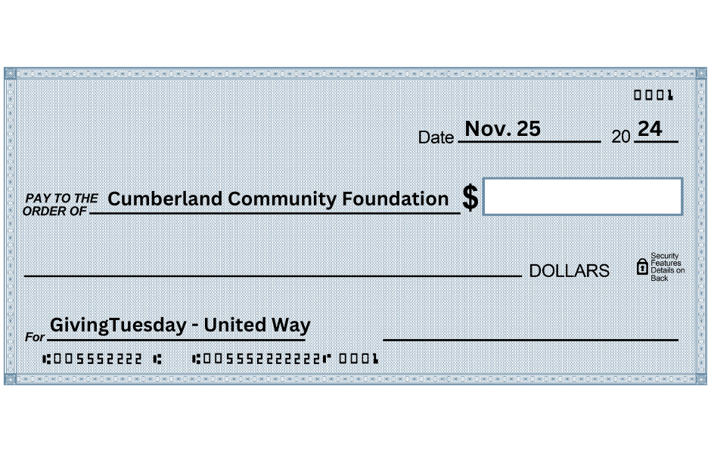
* **Mail to:**United Way of Cumberland County  
  321 Dick St., Suite 107  
  Fayetteville, NC 28301
* **Drop Off:** You can also deliver checks to **CCF, 308 Green Street, Fayetteville, NC 28301** using the secure mail slot on the front of the building (accessed only by CCF staff).
* **Deadline:** Please note that checks must be received by **December 4th at 5 PM** to be eligible for a match.

**3. Donor-Advised Grant**

* Make your grant recommendation payable to **Cumberland Community Foundation** (tax ID: **58-1406831**) and designate it for **GivingTuesday - United Way**.

**4. Stock Gifts**

* For instructions, please call **Cumberland Community Foundation** at **(910) 483-4449** (Mary Holmes x103 or Mary Anne Brooks x106).

**5. Charitable IRA Rollovers**

* Donors aged **70.5 or older** can make direct gifts from their IRA to **Cumberland Community Foundation** for GivingTuesday. Ensure your plan administrator sends the check directly to CCF.
* **Notification:** Call **(910) 483-4449** or email **Gifts@CumberlandCF.Org** with the check amount, plan administrator's name, and the organizations you wish to benefit to ensure prompt acknowledgment.