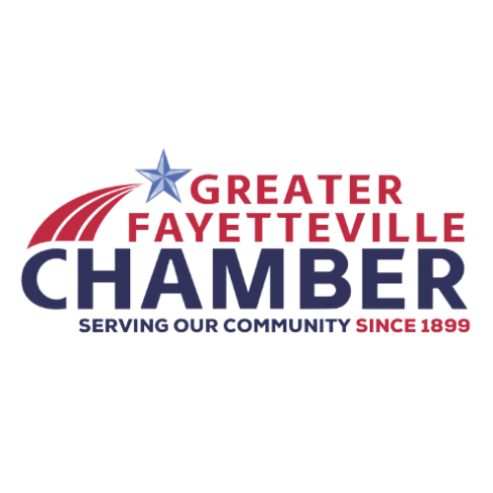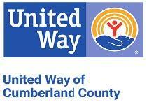

**PRESS RELEASE**

FOR IMMEDIATE RELEASE

**CONTACT INFORMATION:**

United Way of Cumberland County

Ashlee Pearson

Director of Development

910-438-1179 x 225

ashleepearson@unitedway-cc.org

**United Way of Cumberland County to Host Ribbon Cutting and Open House at New Permanent Location**

With the Greater Fayetteville Chamber

**Fayetteville, N.C. (November 22, 2024)** – United Way of Cumberland County is pleased to announce a Ribbon Cutting Ceremony and Open House, hosted in collaboration with the Greater Fayetteville Chamber, to celebrate their recent move to a new permanent location. The event will take place on **Tuesday, December 3, 2024, from 2:00 p.m. to 4:00 p.m.** at their new office located at **321 Dick St., Suite 107, Fayetteville, NC 28301**.

The event will feature light refreshments and provide an opportunity for community members, local business leaders, and supporters to tour the new office space. United Way’s board members will be in attendance to meet and greet guests, share the organization’s future plans, and discuss how they are continuing to address the community’s most pressing needs in education, health, and financial stability.

The Ribbon Cutting Ceremony will begin promptly at 2:15 p.m., followed by the open house and networking. This event is free and open to the public, and all are invited to join in celebrating this milestone.

**- More -**

**Event Details:**

* **Date:** Tuesday, December 3, 2024
* **Time:** 2:00 p.m. – 4:00 p.m.
* **Location:** United Way of Cumberland County, 321 Dick St., Suite 107, Fayetteville, NC 28301
* **Ribbon Cutting Ceremony:** 2:15 p.m.
* **Refreshments:** Light refreshments will be served

For more information, please contact Ashlee Pearson at 910-438-1179 x 225.

**United Way of Cumberland County**

Our mission is to improve lives across Cumberland County by strategically raising and investing resources that successfully impact prioritized human service and health needs while working in effective and innovative partnerships with direct provider agencies. To learn more visit https://www.unitedway-cc.org/

**Greater Fayetteville Chamber**

The Greater Fayetteville Chamber serves as a catalyst for growing a healthy and thriving business community. Through the advocacy of business-friendly public policies, the Chamber fosters diverse and innovative business initiatives that drive economic growth. By building strong collaborative partnerships and delivering valuable programs and services, the Chamber empowers its members to succeed and strengthens the local economy, ensuring Fayetteville remains a vibrant place to live, work, and do business. To learn more visit https://www.faybiz.com/.

###