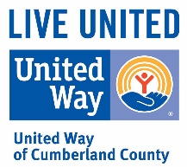 PRESS RELEASE

United Way of Cumberland County

222 Maiden Lane

Fayetteville, NC 27546

Tel 910.483.1179

[www.unitedway-cc.org](http://www.unitedway-cc.org)

September 7, 2021

FOR IMMEDIATE RELEASE:

United Way of Cumberland County (UWCC) has official started their Campaign Kickoff for 2021. This year’s Campaign comes with a great surprise! Thanks to an anonymous, when you become a **payroll deduction donor for at least $5.00 per pay period or if you make a one-time donation of at least $125.00,** you could win a cash prize of **$5,000, and $1,000 going to the UWCC partner program of your choice!**

UWCC will pull 3 names each week starting on Friday October 8th and do that every Friday until November 26th (8 weeks). Don Chase will be announcing the names on the air each week and the big drawing will be made on Friday December 3rd

By giving to the United Way of Cumberland County, we come together as a community to support our local nonprofits, and allow them to focus instead on serving those in need.

28 local programs are funded each year, through an intensive application process. Each year, tens of thousands receive help thanks to United Way donors!

If you would like to become a United Way donor contact Melissa Reid at 483-1179 Ext. 228