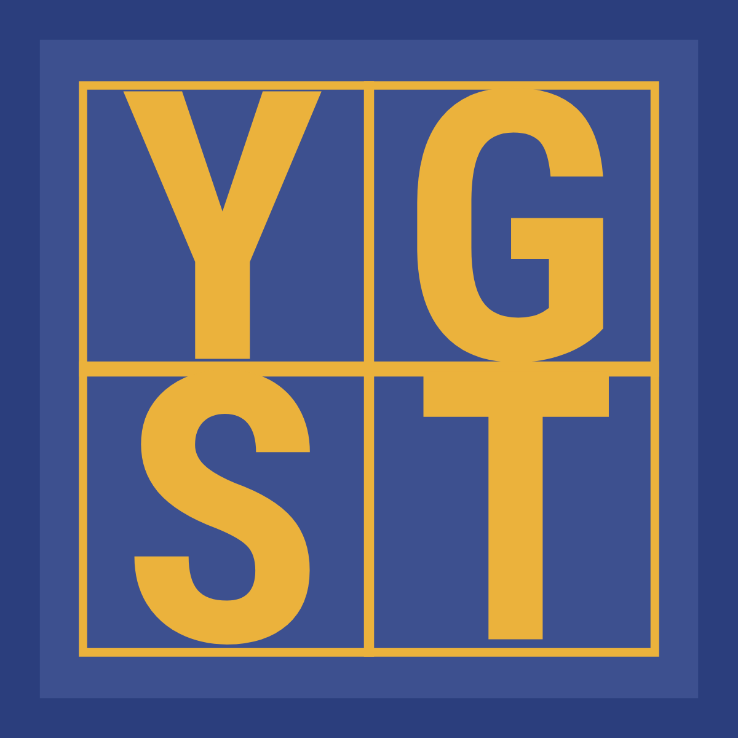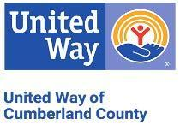

**PRESS RELEASE**

FOR IMMEDIATE RELEASE

**CONTACT INFORMATION:**

United Way of Cumberland County

Crystal Moore - Williams

Community Impact Director

910-483-1179 ext. 229

crystalmmcnair@unitedway-cc.org

**United Way of Cumberland County Opens 2025 Grant Cycle for**

**Youth Growth Stock Trust Funding**

**Fayetteville, N.C. (February 3, 2025)** – The United Way of Cumberland County is now accepting applications for its Youth Growth Stock Trust (YGST) grant funding for 2025. Each year, the YGST provides financial support to local programs, initiatives, and scholarships aimed at benefiting youth in Cumberland County.

Local public schools and 501(c) 3 nonprofit organizations in Cumberland County are encouraged to submit Requests for Funding Proposals (RFPs) for programs that support the well-being and development of young people in the area. Applications for YGST funding are available online atwww.unitedway-cc.org. All applications must be submitted by **March 3, 2025.**

For more information, visit our website or contact Crystal Moore Williams at (910) 483-1179 ext. 229 or crystalmmcnair@unitedway-cc.org.

**About the Youth Growth Stock Trust (YGST)**

The Youth Growth Stock Trust was established in 1992 by the late Robert Short, a self-taught investor and passionate community leader, in response to his concern for the

-More-

well-being of local youth. Having left school at 16 to support his family, Mr. Short wanted to provide the opportunities he never had growing up. His love for the community and his support of United Way led him to create the YGST, ensuring that his legacy would continue to benefit young people in Cumberland County for generations to come.

United Way of Cumberland County serves as the Trust Beneficiary, and income from the YGST is distributed annually to local programs that meet the needs of youth. The YGST Grants Committee reviews applications and makes funding recommendations to the United Way Board of Directors.

The YGST is entirely separate from United Way’s regular fundraising campaigns, further expanding the organization’s impact in the community.

**United Way of Cumberland County**

Our mission is to improve lives across Cumberland County by strategically raising and investing resources that successfully impact prioritized human service and health needs while working in effective and innovative partnerships with direct provider agencies. To learn more visit https://www.unitedway-cc.org/

### End ##